**Program Code:-**

Server:

import java.io.*;

import java.net.*;

public class Tserver{

public static void main(String ags[]) throws IOException{

DataInputStream dis=new DataInputStream(System.in);

ServerSocket ss=new ServerSocket(2500);

Boolean send=false;

byte[] buf=new byte[100];

byte[] buf2=new byte[100];

String str,str2;

while(true){

Socket s =ss.accept();

InputStream in=s.getInputStream();

OutputStream out=s.getOutputStream();

if(send){

out.write(buf);

send=false;

}

else{

int d=in.read(buf2);

str2=new String(buf2,0,d);

FileInputStream fis=new FileInputStream(str2 + ".txt");

System.out.println("THE REQUESTED FILE IS : " +str2 + ".txt");

int de=fis.available();

for(int i=0;i<de;i++){

buf[i]=(byte)fis.read();

}

send=true;

}

}

}

}

Client:

import java.io.*;

import java.net.*;

public class Tclient{

public static void main(String ags[]) throws IOException{

DataInputStream dis=new DataInputStream(System.in);

boolean send=true;

byte[] buf=new byte[100];

byte[] buf2=new byte[100];

String str,str2;

int count=0;

while(count<=1){

Socket s =new Socket(InetAddress.getLocalHost(),2500);

InputStream in=s.getInputStream();

OutputStream out=s.getOutputStream();

if(send){

System.out.println("Enter the file name : ");

str=dis.readLine();

buf=str.getBytes();

out.write(buf);

send=false;

}

else{

int d=in.read(buf2);

str2=new String(buf2,0,d);

System.out.println("The Content of the file is : ");

System.out.println();

System.out.println(str2);

send=true;

}

count++;

}

}

}

**Output:-**

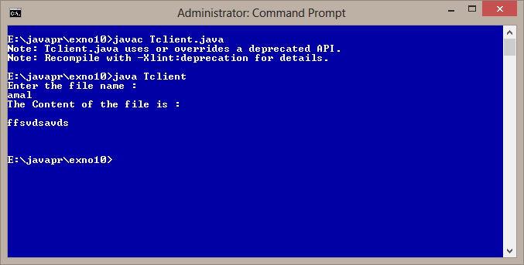

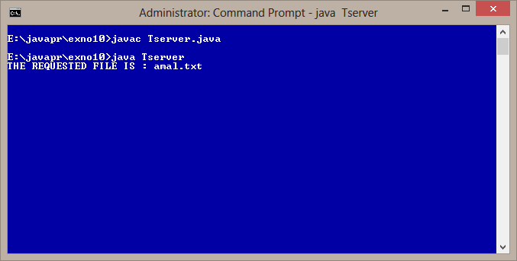

**Result:-**

The above program has been executed and the output has been obtained